**Instructions for using the microscope from Leica Microsystems**

1. Double check to see if the small silver USB drive labeled Leica (CmStick) is in the computer.
2. Move the camera to the microscope you are planning to use and make sure to replace the cap on the unused microscopes.
   1. Compound Microscope in Director’s office = LAXCO 3000
   2. Dissecting Microscope on the left with Z-stacking capabilities = Leica M165C
      1. Lens options 0.5X and 1.0X
   3. Dissecting Microscope on the right = Leica MZ6; on a boom stand with drawing tube attachment. You may need to reattach the camera mount in order to take images if the drawing tube is on. Please see the Collections Manager for assistance.
      1. Lens options 0.32X, 0.5X, and 1.0X

**Please be very careful switching lenses! They are over $1,000 each. Use both hands and do not touch the lenses. Please see the Collections Manager for assistance switching between lenses.**

The instructions below are specific for the Leica M165C. If you are using one of the other microscopes there will be fewer steps and buttons to press.

1. The following four things should be turned on in this order.
   1. **The computer** (Login with your UT NetID and Password. Visitors and Volunteers please see the Collections Manager for the guest login and password.)
   2. **The microscope** (Leica M165C - the switch is on the lower back of the column)
   3. **The camera** (on/off switch located on the back of the camera).
      1. The light on the side needs to turn green. If the light remains orange, then check the back of the camera. The second switch should be set to PC, not HD. Switch the toggle to PC and then the light should be green.
   4. **The light ring on the objective lenses**.

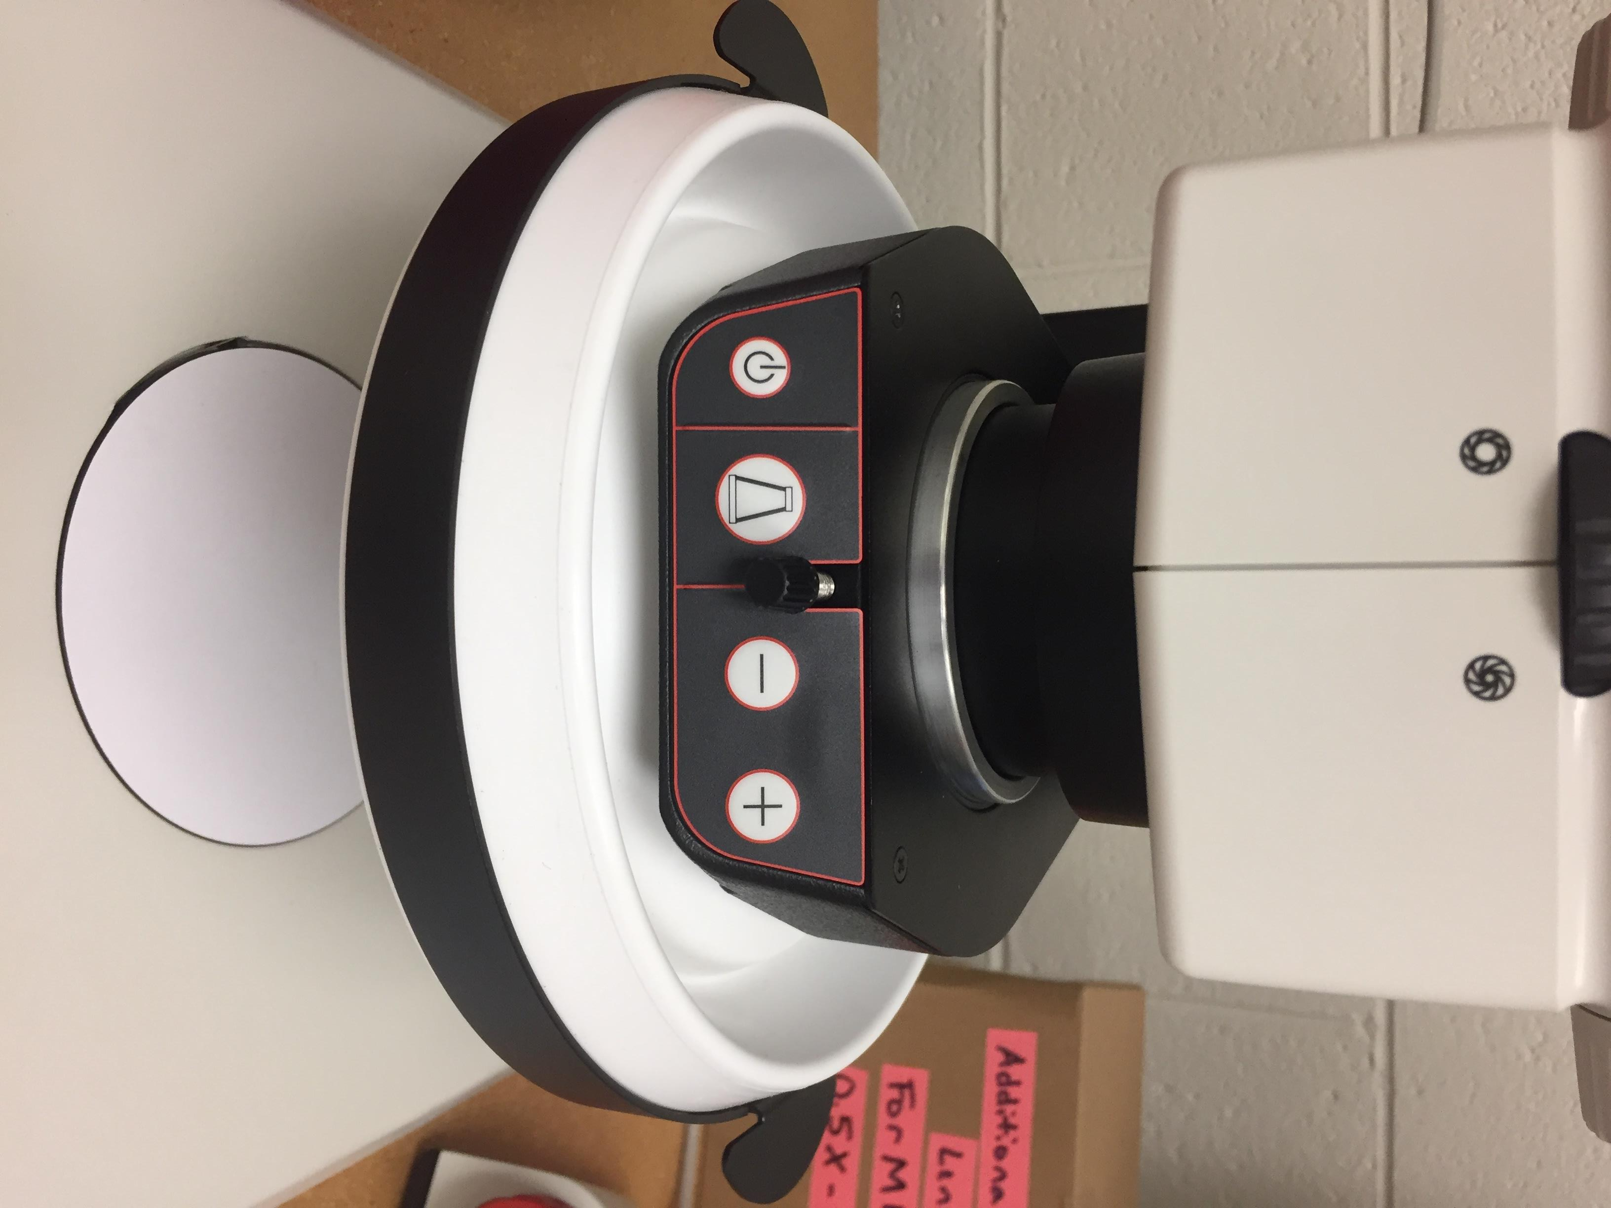

Increase/Decrease Light Intensity

Light Button: illuminates top light, bottom light, & both

Light Ring: On/Off Switch

1. Put your sample on stage plate in the center of the microscope base.
2. Focusing your sample.
   1. Shut off the path to the camera by pushing the metal bar located on the left side of the eye pieces in toward the microscope.
   2. Open the diaphragm by turning the black wheel, located on the front of the microscope, to the left.
   3. Turn the Focus Knob to the smallest reading (0.73).
   4. Press the **black button** (toggle: course/fine/extra fine), then turn the **big**, **red knob** for Coarse/Fine focus.
3. Open the light path to the camera by pulling the metal bar (to the left of the eye pieces) all the way out.
4. Double click LASX icon on the desktop.
5. Be sure the Configuration is set to DefaultDynamicWideFieldTree.xlhw
6. Set Choose Configuration to the microscope you are using (Ex. Leica M165C).
7. Load settings at startup: OFF
8. Click OK



1. Z-Drive - Click No. (You did not adjust the clamps setting limits.)
2. Watch the loading screen and be sure that the microscope you selected scrolls by. If M125 scrolls through, this is an error. The microscope will need to be shut down and restarted.
3. Errors commonly occur at this stage. Shut down the program and restart. If that doesn’t work, then shut down the program, shut down the microscope, and restart. Or see Help in the top right corner -> Contents -> Graphical User Interface -> Simplified User
4. The display should be in the **Acquire** tab with the screen displayed like this (the 1st image below), in Easy Operation Mode. If not, click on **Configuration** tab, then Check the box to Activate Easy Operation Mode (the 2nd image below).





1. Click the **Acquire** tab, click on the **Live Image Arrow** at the bottom left edge of the screen to start live acquisition of your specimen.
   1. If the live image that appears looks like the inner workings of a clock, close the software, turn off the camera, and make sure the second switch on the camera is set on PC, not HD. Turn the camera back on and re-open the software.



Live Image play button

1. Make sure you can see your specimen and your images look good.
   1. Click on the **Image button** to open the pull out menu to adjust the image.
   2. Click on the **Auto exposure** button. It should stay red. (Under **Camera Preferences,** make sure that easy mode is turned off.)
      1. **Image Format:** 10.0MP
      2. **Live Format:** 1.9MP
      3. **Color Mode** - Checked
      4. **Camera Profile:** *Brightfield
   3. If the colors or background whiteness is off then follow the instructions below.
      1. Click on the **Show/Hide Color Controls** button.
      2. Use the color controls, saturation, and **White Balance** button to adjust the colors until your specimen looks realistic. You can use the **White Balance** with the specimen in place or if you switch the camera profile to white balance with a clean sheet of paper. If the light is too intense you will get an error message. You can always use the **Reset** button to go back to the original colors.

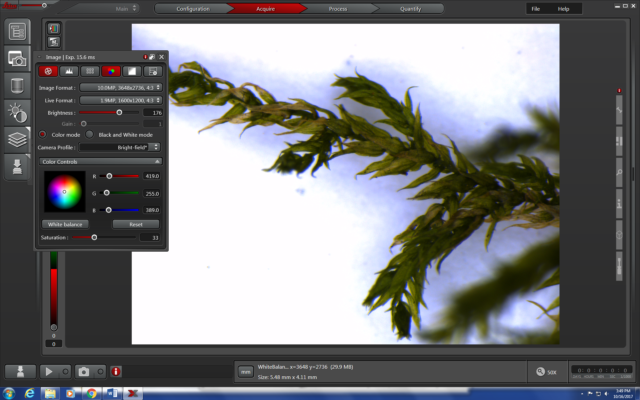

1. Now a live, visible image of your specimen should be displayed on the screen.

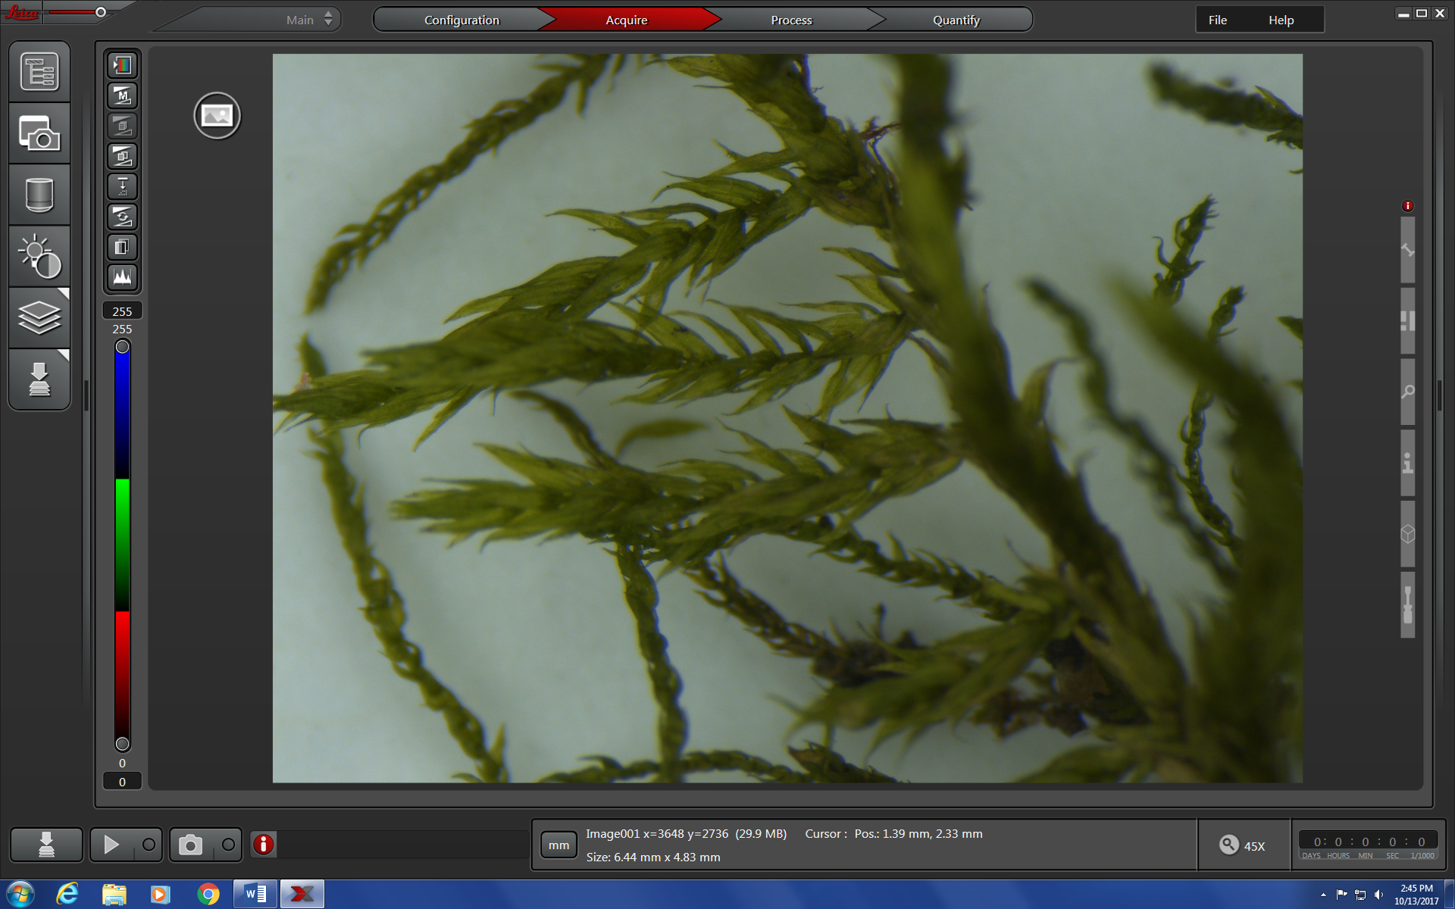

1. Setting the folder for saving your images.
   1. Click on the top left button (Explorer) that opens the **Open Project** menu.
   2. Click on the **Project settings** button and **Default settings for new projects.**
   3. Give your project a name.
   4. Be sure **Auto-Save** is set to ON.
   5. Direct your images to be saved into the **Working folder** of your choice.
   6. You may also set a **User defined image name**.
   7. Click on the **New Project** icon.

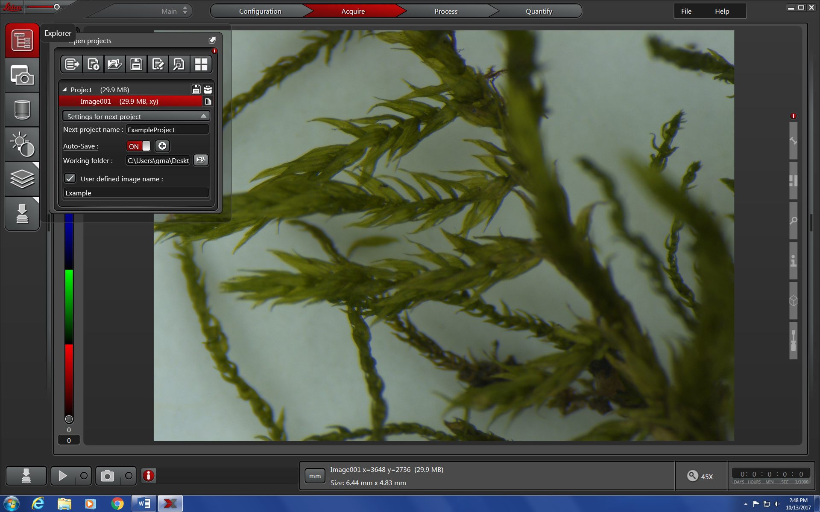

1. To add a Scalebar, hover over the top expandable tab on the right side of the screen and click **Scalebar.**
   1. **You can modify all aspects of the scalebar in this menu.**

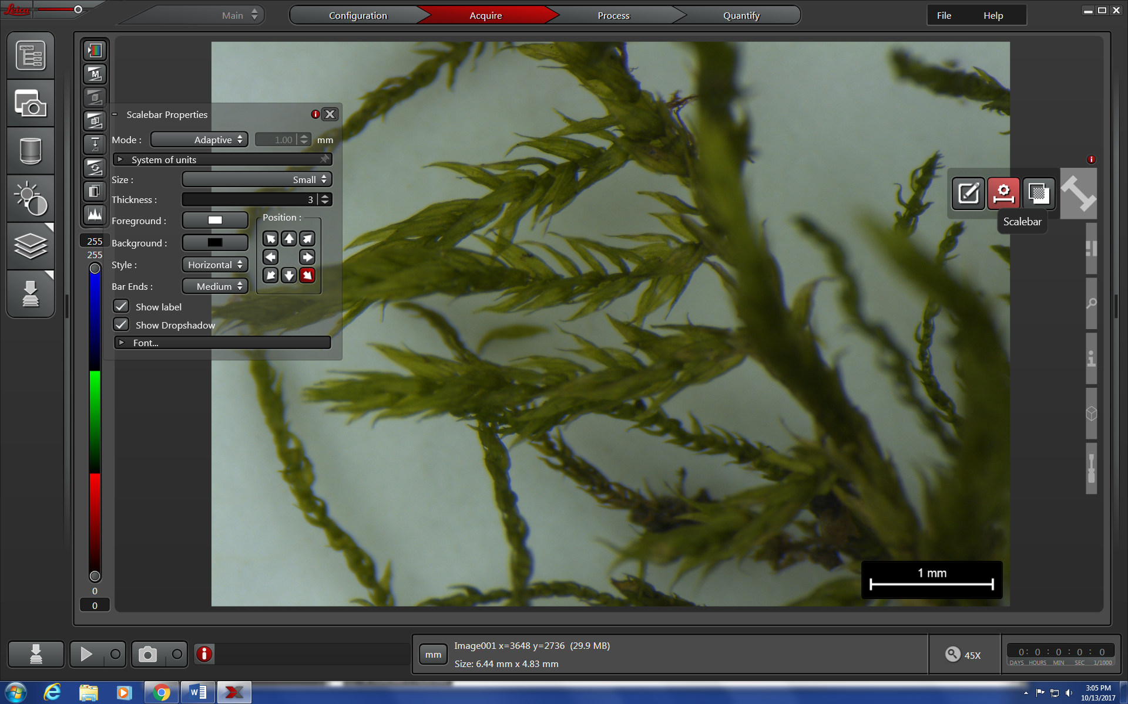

**Scalebar** button

1. To add annotations (distance line, line, arrow, or text), hover over the top expandable tab on the right side of the screen and click **Annotation Tools**.
   1. **You can modify aspects of the Annotation Tools in this menu.**
   2. If you want to change the units shown by the measuring tool select the **Configuration** tab at the top 🡪 User Config 🡪 User interface 🡪 System of units. You can select the units here. Then go back to the **Acquire** tab at the top.

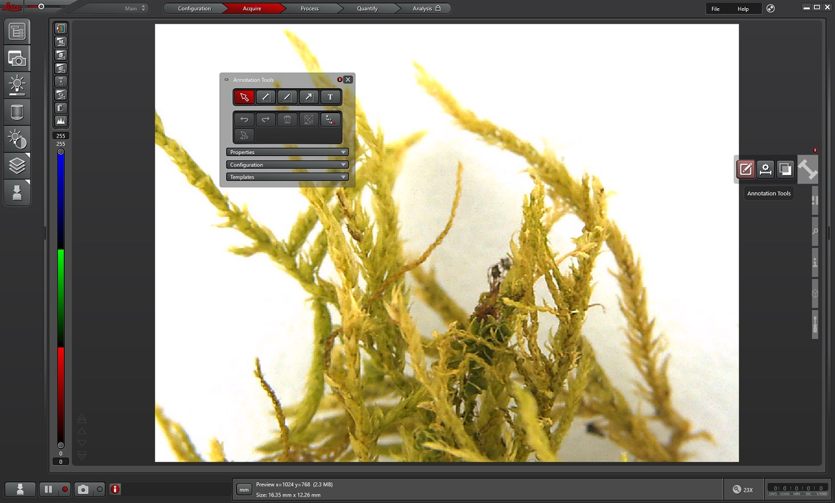

**Annotation Tools** button

1. To make a scalebar or any annotation tools go away after using them, hover over the top expandable tab on the right side of the screen and click **Show or hide individual overlays.** Click on the overlay you want to show (red eye appears on icon) or hide (plain icon without a red eye).

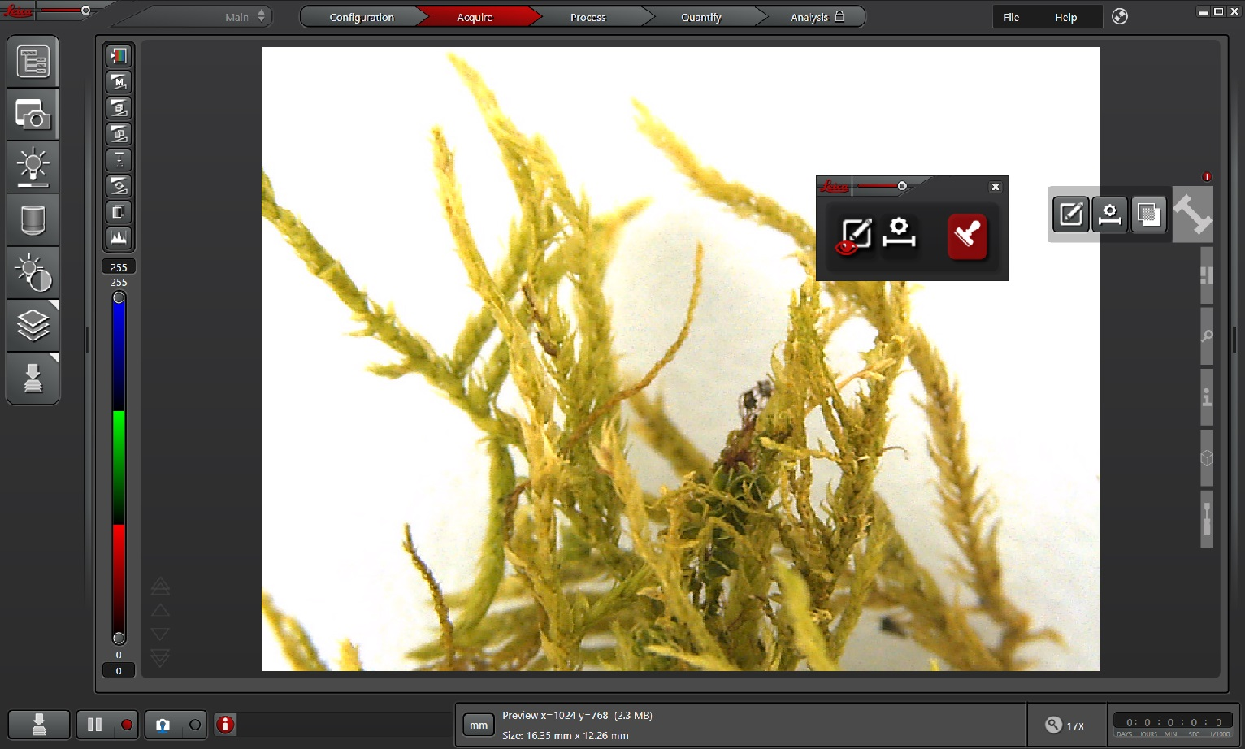

**Show or hide**

**individual overlays**

1. Click **Capture Single Image** to acquire photo under your active project folder.
   1. Do not touch the table while the camera is taking the images. Any vibrations will make your images blurry.
   2. If you have any overlays you want included in the image (scalebar or annotation tools), you’ll need to make sure to merge them by hovering over the top expandable tab on the right side of the screen and clicking **Show or hide individual overlays** (also see step 22). Within popup menu, select the **Enables/Disables burn-in functionality** (the stamp icon, red=it’s enabled). Once enabled, the **Capture Single Image** icon with have a blue stamp as shown below.

**Capture Single Image** button

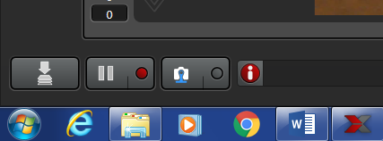

1. Save these images as TIFFs by right clicking on the entire project title (e.g Ma1) and export as Tiff.

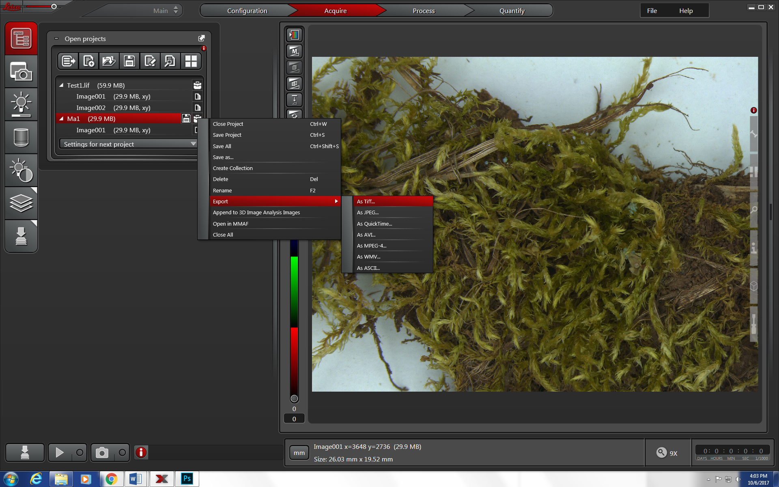

1. When exporting, make sure to check: Overlay channels, Lossless data compression, Use Directories, and then check the desired destination folder. By default, it will be set to your working folder.

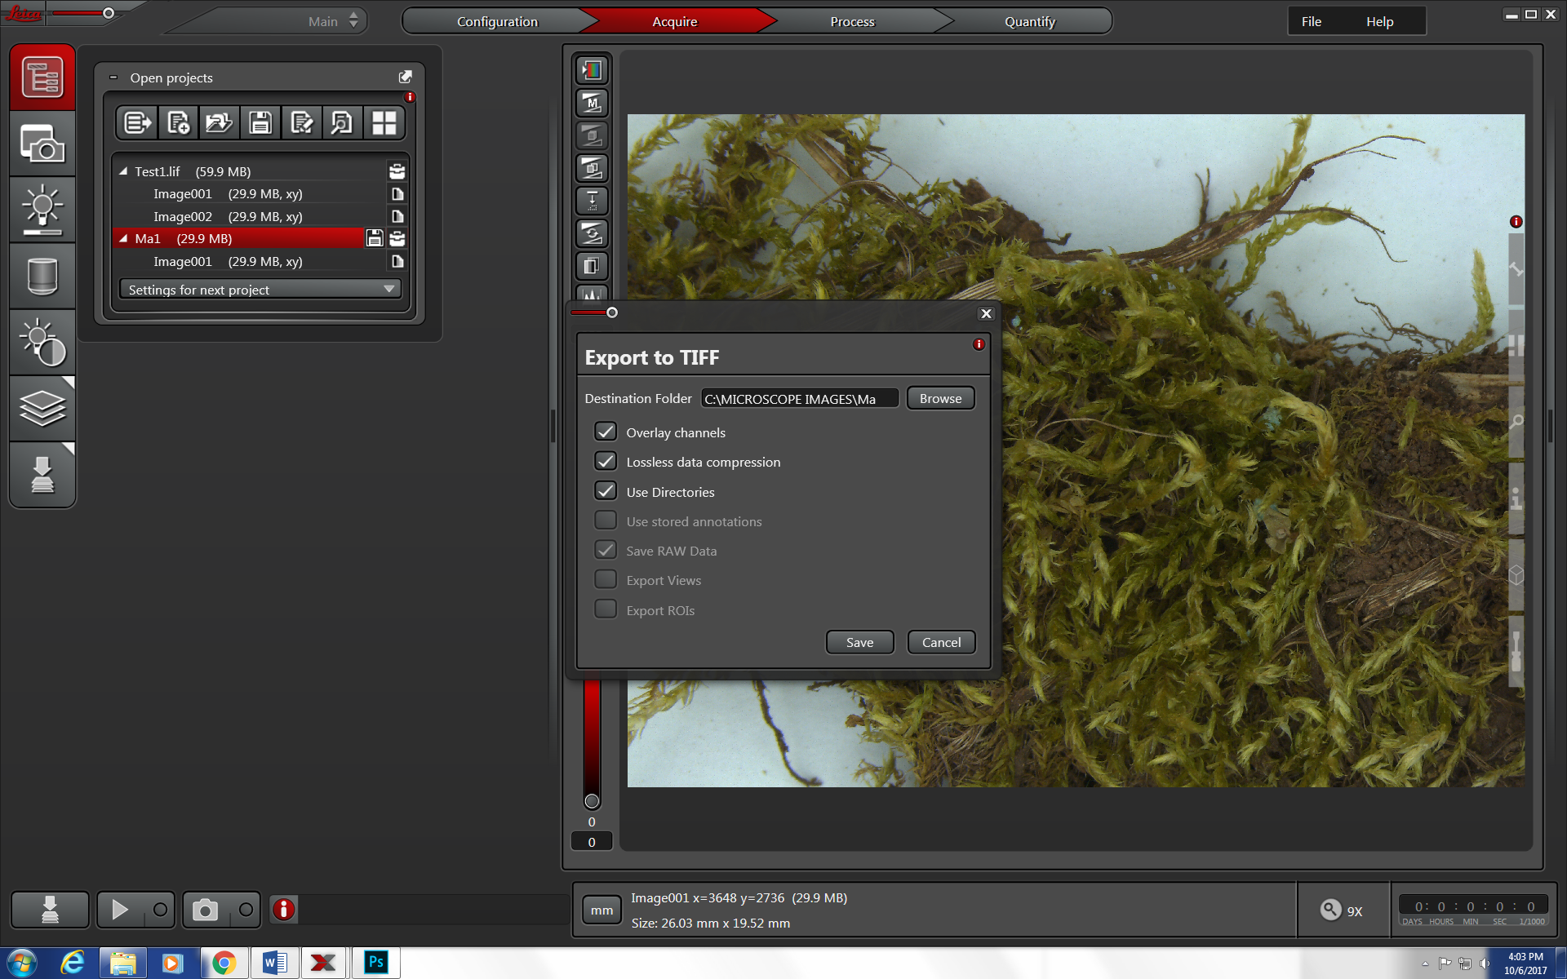

**Z-Stacking**

The idea here is to take multiple images of your specimen at different focal depths and then merge them into a single image so that your specimen is in focus, from the top to the bottom

1. Click on the **Z-stack** button
   1. Click **Custom**.
   2. Use the large red focusing wheel to focus to the top of your specimen and then a bit farther until it is slightly out of focus.
   3. Click **Begin** to set the top position for the photos.
   4. Then use the large red focusing wheel to focus to the bottom of your specimen and then a bit farther until it is slightly out of focus.
   5. Click **End** to set the bottom position for the photos.
   6. Check to be sure the **System Optimized** button is checked. The **Nr. of Steps** will tell you how many images the computer is planning to take. If this number is very large then it will take the microscope a long time to take all the images. If the number is too big, then check the **Nr. of Steps** button and adjust the number to a manageable size that will optimize your time spent on the microscope, so that you do not have to wait as long, but the more images in the stack, the higher the quality will be. The **Z-Step Size [um]** tells you how much distance there will be between each photo.

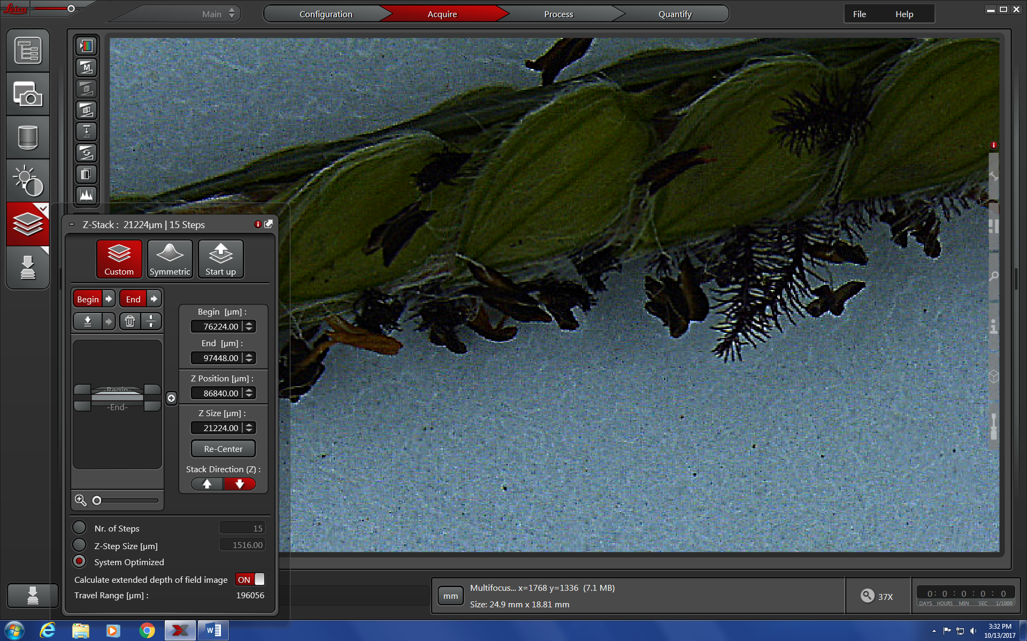

* 1. Click the **Start Experiment** button to start taking z-stacked images of your specimen. Do not touch the table while the camera is taking the images. Any vibrations will make your images blurry.
  2. Once the z-stacked images have been taken and the software is done “Processing image results,” you can view the fully z-stacked image under your project -> Multifocus Image.

**Start Experiment** button

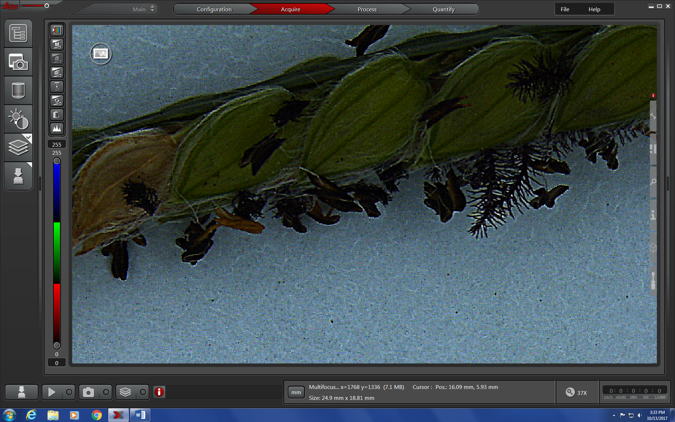

1. Z-stacked images are saved in the same manner as individual images. See steps 19 & 24-25 above.
2. Remember to turn off the camera and microscope and then exit the Leica software when finished!!
3. Log off the computer when you are done. Please do not shut down the computer. It should go to a blue screen with **CTRL + ALT + DELETE** on the screen.